Mixed Boundary
# Source: AI Source: Provided by: [Data Path: Persons Table -> ID Column: 1, Name_En Column: Motasem Essam] -> From: [ChatGPT] on [7/25/2026]
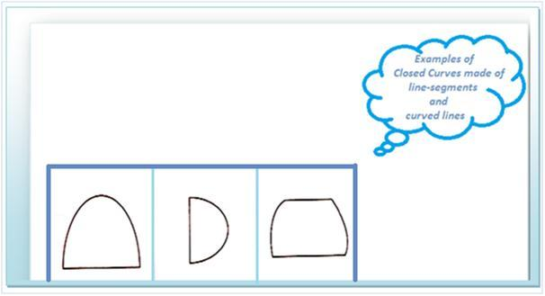
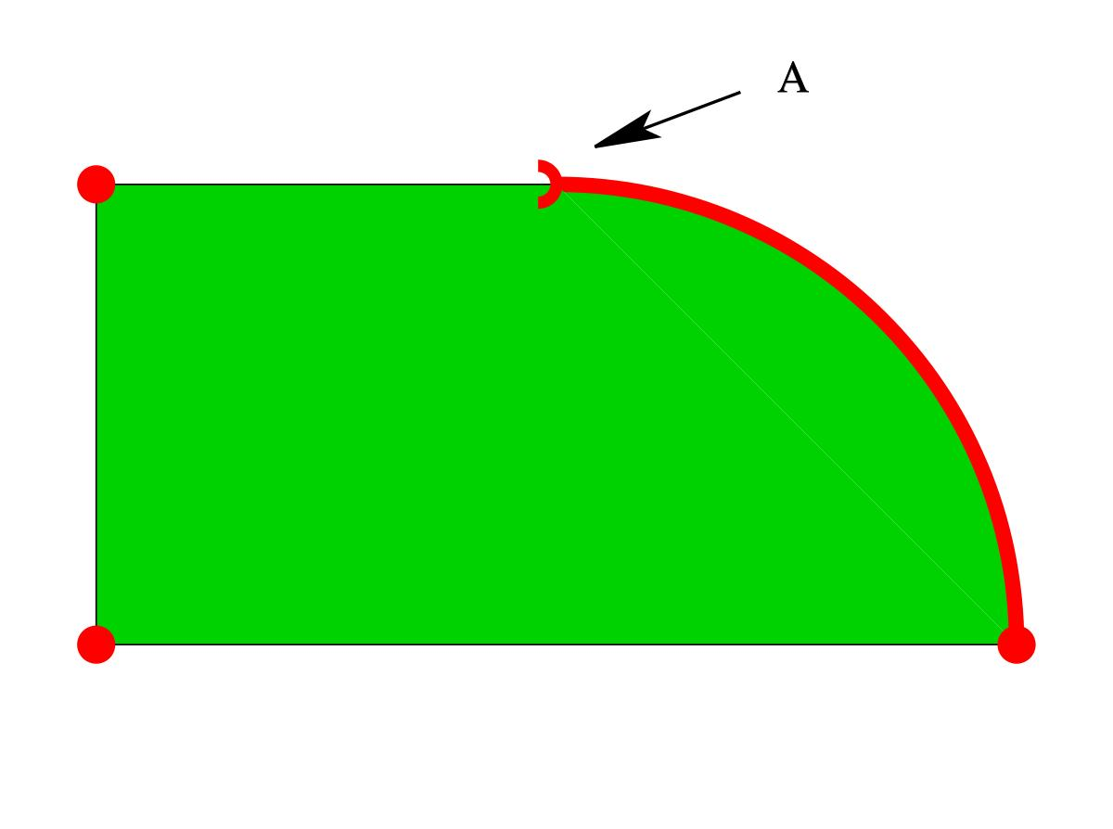
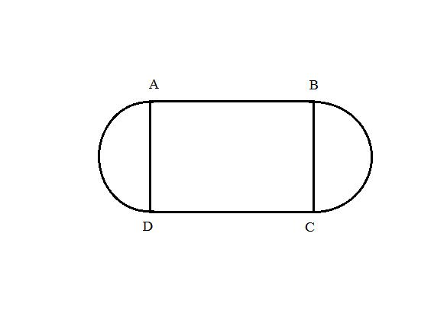
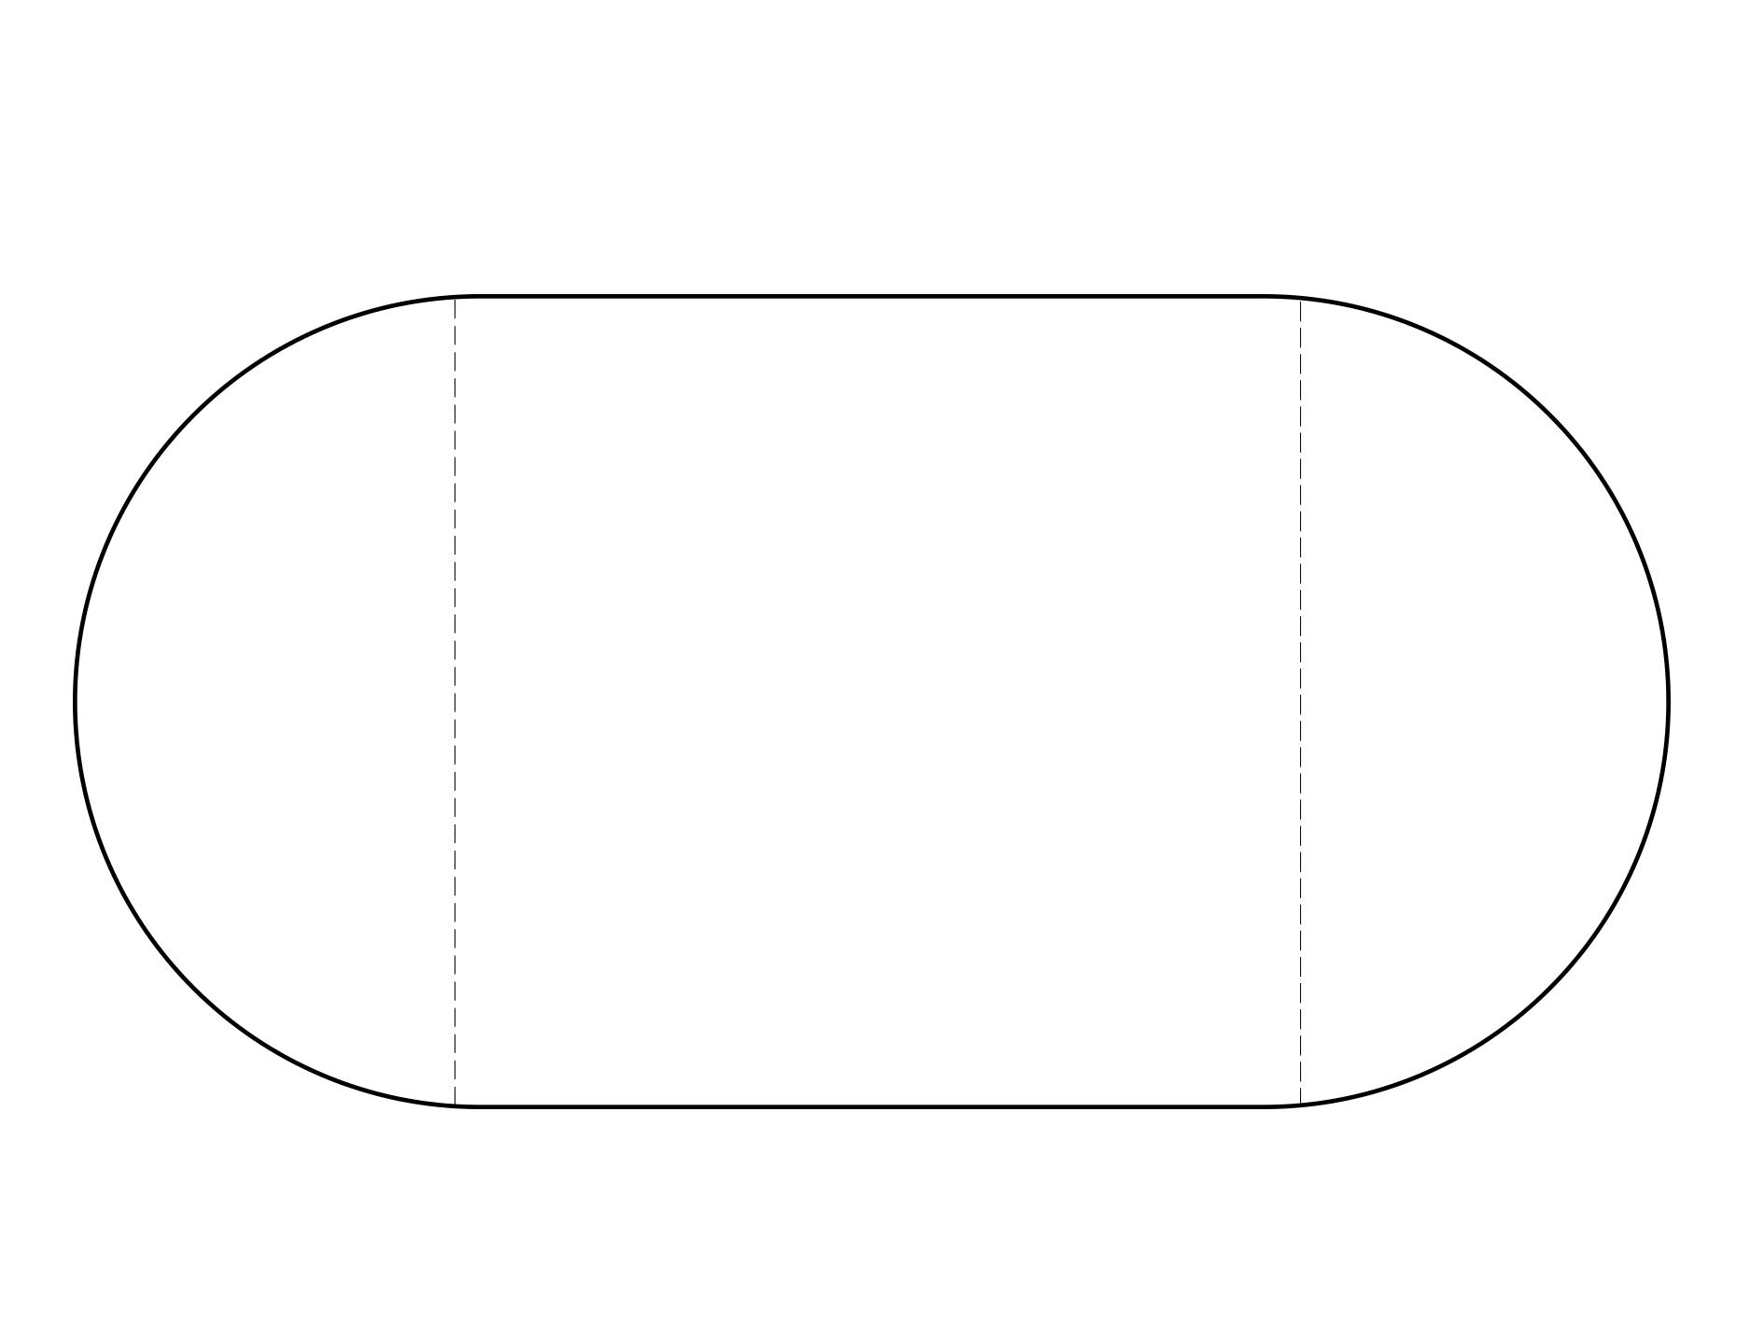

Definition
# Source: AI Source: Provided by: [Data Path: Persons Table -> ID Column: 1, Name_En Column: Motasem Essam] -> From: [ChatGPT] on [7/25/2026]
A Mixed Boundary is a boundary composed of both straight line segments and curved sections. Instead of being entirely straight or entirely curved, a mixed boundary combines different types of geometric edges to form the boundary of a figure.
A mixed boundary may be:
- Closed, enclosing a region.
- Open, having one or more open ends.

Characteristics
# Source: AI Source: Provided by: [Data Path: Persons Table -> ID Column: 1, Name_En Column: Motasem Essam] -> From: [ChatGPT] on [7/25/2026]
A mixed boundary:
- Contains both straight and curved parts.
- May be open or closed.
- Can enclose a bounded region if it forms a closed loop.
- Has length but no thickness.
- Contains infinitely many points.
- Is commonly used to model real-world objects with both flat and curved edges.

Illustration

Closed Mixed Boundary
# Source: AI Source: Provided by: [Data Path: Persons Table -> ID Column: 1, Name_En Column: Motasem Essam] -> From: [ChatGPT] on [7/25/2026]
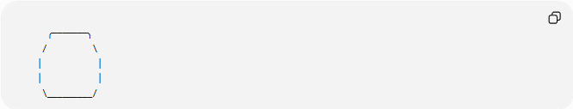
╭───────╮
/ \
│ │
│ │
\_________/
- Top: Curved boundary.
- Bottom: Straight boundary.
Together they form a closed mixed boundary.

Another Example
# Source: AI Source: Provided by: [Data Path: Persons Table -> ID Column: 1, Name_En Column: Motasem Essam] -> From: [ChatGPT] on [7/25/2026]
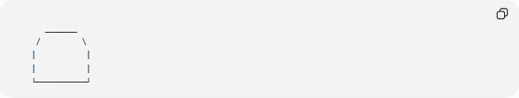
_______
/ \
| |
| |
└───────────┘
- Curved top.
- Straight sides.
- Straight bottom.

Mathematical Representation
# Source: AI Source: Provided by: [Data Path: Persons Table -> ID Column: 1, Name_En Column: Motasem Essam] -> From: [ChatGPT] on [7/25/2026]
A mixed boundary is typically described as a combination of:
- Line segments.
- Curves.
Example:
Straight segment:
$$\overline{AB}$$
Curved arc:
$$\overset{⌢}{BC}$$
Straight segment:
$$\overline{CA}$$
Together they form a mixed boundary.

Examples
# Source: AI Source: Provided by: [Data Path: Persons Table -> ID Column: 1, Name_En Column: Motasem Essam] -> From: [ChatGPT] on [7/25/2026]
Example 1 – Semicircle
A semicircle consists of:
- One curved arc.
- One straight diameter.
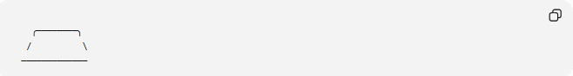
╭────────╮
/ \
─────────────

Example 2 – Archway
An architectural arch:
- Curved top.
- Straight vertical sides.

Example 3 – Stadium Shape
A stadium outline:
- Two semicircles.
- Two straight sides.

Example 4 – Rounded Rectangle
A rounded rectangle combines:
- Straight edges.
- Rounded corners.

Properties
# Source: AI Source: Provided by: [Data Path: Persons Table -> ID Column: 1, Name_En Column: Motasem Essam] -> From: [ChatGPT] on [7/25/2026]
1. Combination of Edge Types
A mixed boundary always includes at least:
- One straight portion.
- One curved portion.

2. Flexible Shape
It can represent many natural and engineered objects.

3. May Be Closed or Open
Closed:
- Rounded rectangle.
- Stadium.
Open:
- A line joined to an arc without closing.

4. May Enclose a Region
Only if the boundary forms a closed loop.

Real-World Examples
# Source: AI Source: Provided by: [Data Path: Persons Table -> ID Column: 1, Name_En Column: Motasem Essam] -> From: [ChatGPT] on [7/25/2026]
Mixed boundaries appear in:
- Stadiums.
- Arches.
- Bridges.
- Rounded windows.
- Doorways.
- Automobile bodies.
- Aircraft wings.
- Product packaging.
- Smartphones with rounded corners.
- Swimming pools with curved ends.

Applications
# Source: AI Source: Provided by: [Data Path: Persons Table -> ID Column: 1, Name_En Column: Motasem Essam] -> From: [ChatGPT] on [7/25/2026]
Mixed boundaries are used in:
- Plane Geometry
- Coordinate Geometry
- Engineering
- Architecture
- Mechanical Design
- Industrial Design
- CAD (Computer-Aided Design)
- Computer Graphics
- Product Design
- Robotics

Advantages
# Source: AI Source: Provided by: [Data Path: Persons Table -> ID Column: 1, Name_En Column: Motasem Essam] -> From: [ChatGPT] on [7/25/2026]
Studying mixed boundaries helps to:
- Model realistic objects.
- Combine geometric shapes.
- Design engineering components.
- Compute perimeter of composite figures.
- Analyze complex boundaries.

Limitations
# Source: AI Source: Provided by: [Data Path: Persons Table -> ID Column: 1, Name_En Column: Motasem Essam] -> From: [ChatGPT] on [7/25/2026]
A mixed boundary:
- Is more complex than purely straight or curved boundaries.
- May require multiple formulas for perimeter.
- Often requires calculus for exact curved lengths.

Comparison with Other Boundary Types
# Source: AI Source: Provided by: [Data Path: Persons Table -> ID Column: 1, Name_En Column: Motasem Essam] -> From: [ChatGPT] on [7/25/2026]
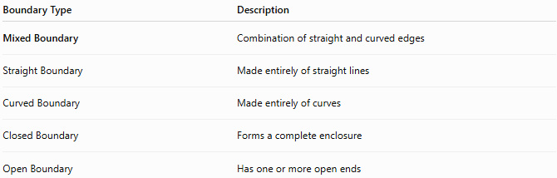
Boundary Type | Description
Mixed Boundary | Combination of straight and curved edges
Straight Boundary | Made entirely of straight lines
Curved Boundary | Made entirely of curves
Closed Boundary | Forms a complete enclosure
Open Boundary | Has one or more open ends

Key Points
# Source: AI Source: Provided by: [Data Path: Persons Table -> ID Column: 1, Name_En Column: Motasem Essam] -> From: [ChatGPT] on [7/25/2026]
- A Mixed Boundary combines:
  - Straight edges.
  - Curved edges.
- It may be:
  - Open.
  - Closed.
- Common examples include:
  - Semicircles.
  - Stadiums.
  - Rounded rectangles.
  - Arches.
- Closed mixed boundaries can enclose bounded regions.

Conclusion
# Source: AI Source: Provided by: [Data Path: Persons Table -> ID Column: 1, Name_En Column: Motasem Essam] -> From: [ChatGPT] on [7/25/2026]
A Mixed Boundary is a boundary formed from a combination of straight line segments and curved sections, allowing the creation of more complex geometric figures than those with only one type of edge. Mixed boundaries are widely used in plane geometry, coordinate geometry, engineering, architecture, industrial design, CAD, computer graphics, robotics, and product design, where they provide realistic models for objects that combine flat and curved surfaces.

